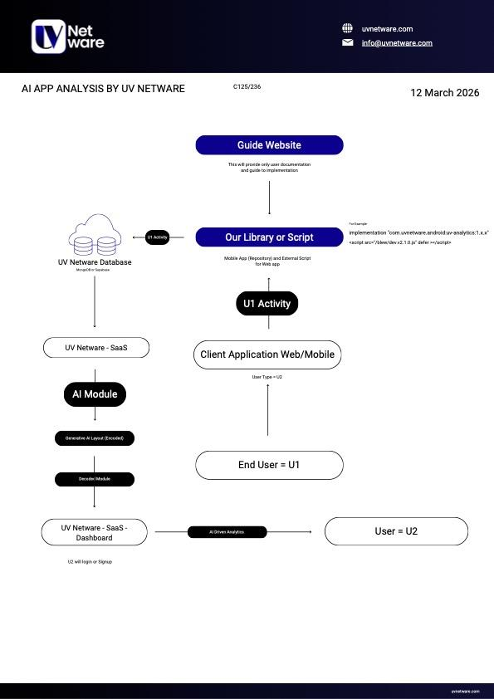

- Step I (U1 activity to Database)
- Creating a light JavaScript file for listening to events by U1
- Use FastAPI to receive these events
- Use MongoDB to receive the events from the API
- Step II (Firebase authentication)
- Step III (AI Module)
- Fetch the data of U1 activity for the U2 client from MongoDB
- Feed this data into an LLM (like ChatGPT, Gemini, or an agentic workflow) with a prompt to analyze the behaviour
- We force the LLM to output its analysis in a strict JSON format
- Backend takes the raw JSON file and translates it for UI
- Step IV (Data to U2)
- log in via firebase
- Based on the JSON, the frontend renders the charts and summaries

Dashboard
- Eraser.io type workflow to the client, showing how their data is being used
- Most visited link
- Link with the most time
- Link with the most clicks on the buy button
- Traffic time on the main website
- links with most view time
- Graphs (traffic time)
- Summary ( based on given data, recommendation given by LLM)
- Chatbot

Shubham Suggestions :-

1. Introduce Data Preprocessing Layer :- Add a preprocessing step before sending data to the AI module. Like instead of passing raw U1 events directly, aggregate and structure the data (e.g., total clicks, time spent, most visited pages).
MongoDB → Preprocessing → AI → Store → Dashboard
Benefit:
Reduces noise in raw event data
Improves quality and accuracy of AI insights
Reduces token usage and cost for LLM processing
2. Introduce Caching Layer :- Cache AI-generated insights and frequently accessed analytics using an in-memory store like Redis.
AI Output → Cache (Redis) → Dashboard
Benefit:
Faster dashboard response time
Reduces repeated database reads
Avoids unnecessary recomputation of insights
In total, we can add a preprocessing layer to clean and aggregate user activity data before AI analysis, and introduce caching to improve performance and reduce system load.

Aditya Suggestions:
- Instead of only text based recommendations, can also add text based analytics like traffic peaked on tuesday evening

